Phase 3 · Fix & Assure
Exercise 10: AI-Assisted Code Review: /review and /security-review
Dev cycle | Assure (review)
CC features | /review, /security-review, the senior-engineer review prompt, fix-and-re-review loop
Time | 35 min
You produce | A reviewed, hardened ExpenseFlow with the top issues fixed and confirmed

Objective
Code review is a manager's highest-value skill: you do not read every line, you ask the right questions and recognise a good answer. You will run Claude Code's built-in review commands, then push past a too-gentle first pass with a sharper prompt, fix the top issues, and re-review to confirm the fixes held.
Walk-through
1 | Run the built-in review
Claude Code ships review commands. Run the general one first across your current changes.
Inside the session / Claude Terminal
PS> /review
VALIDATE /review returns a structured set of observations on your working changes: style, possible bugs, missing handling. Read it, but do not stop here.
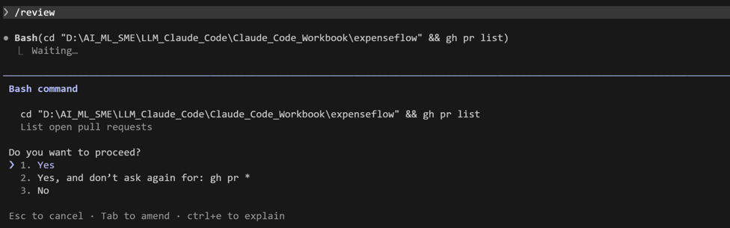
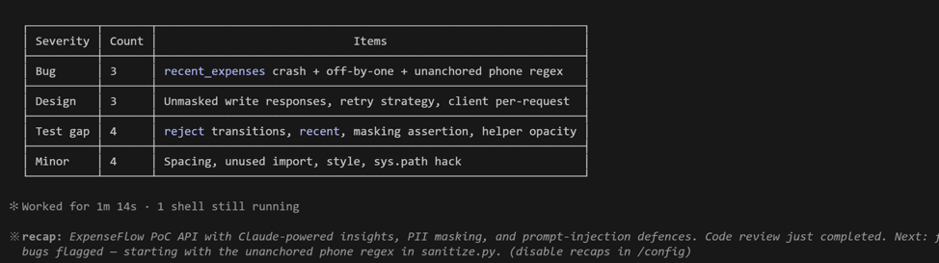
2 | Run the security pass
Then the security-focused review, which targets a different class of problem.
Inside the session
PS> /security-review
VALIDATE /security-review flags security-relevant issues: secret handling, input validation, the auth comparison, error messages that leak detail. Note anything touching the .env or the API key.
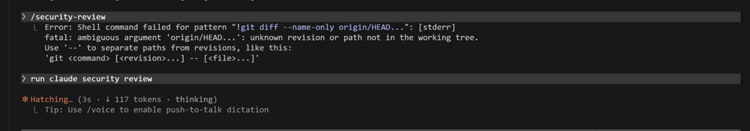

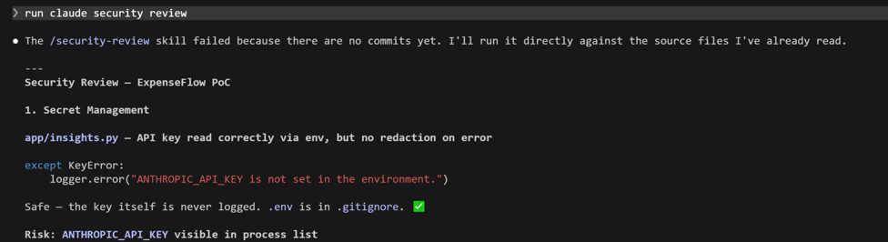

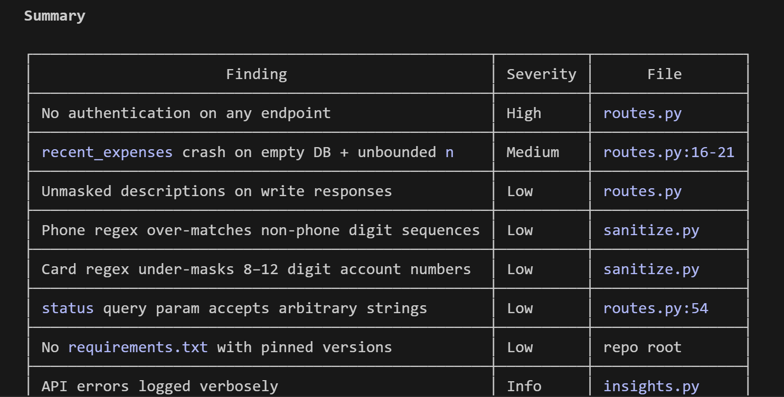

3 | Push for a sharper review
Built-in reviews can be gentle. Use the review prompt that forces ranked severity, so the signal rises to the top.
Type this prompt into Claude Code
Review the whole ExpenseFlow codebase as a senior engineer preparing it for production. List every issue you find ranked by severity (critical, high, medium, low). For each: the file and line, why it matters, and the smallest fix. Be ruthless about input validation, hardcoded values, missing error handling, and untested paths. Do not be polite.
VALIDATE You get a ranked list with file and line references. Typical finds: missing validation on the status filter, no max length on description, the n parameter on recent/{n} unbounded, error responses too verbose. If the list is short and soft, reply 'this is too gentle, look harder at the write endpoints'.
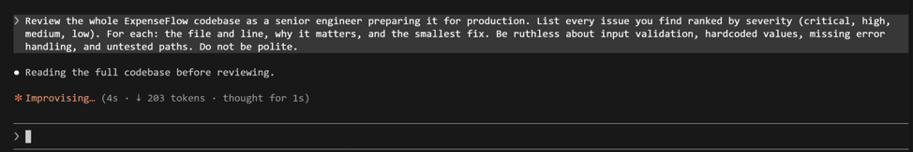

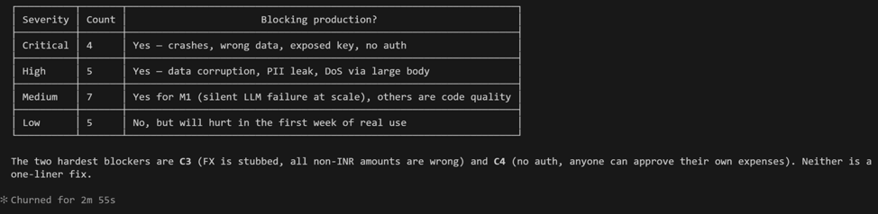
4 | Fix the top three, minimally
Do not fix everything. Pick the three highest-severity issues and have Claude apply minimal, reviewed edits one file at a time.
Type this prompt into Claude Code
Fix only the top three critical/high issues from your review. Make minimal edits, show me each diff before applying, and do not change anything unrelated.
VALIDATE Three targeted diffs, each addressing one ranked issue. You approve each one after reading it. Unrelated code is untouched.
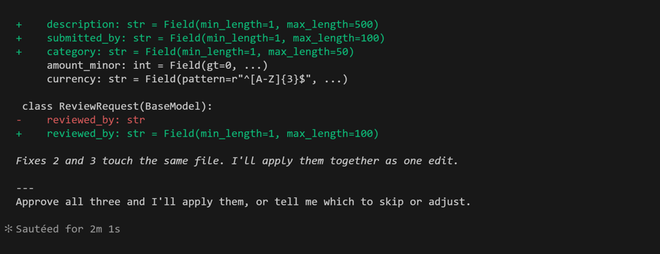
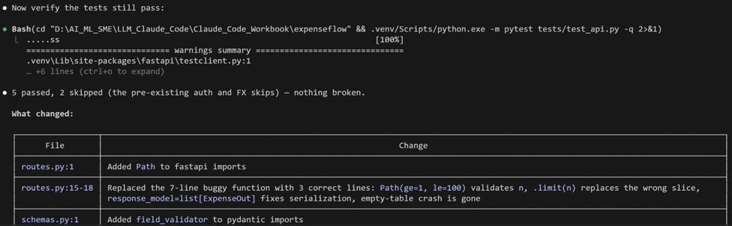
5 | Re-review and re-test
Confirm the fixes held and introduced nothing new. A fix that breaks a test is not a fix.
Inside the session, then in terminal / In Claude Terminal
PS> /review
PS> python -m pytest -q
VALIDATE The re-review shows the three issues resolved and flags no new regressions. pytest is still green. If a test now fails, the fix had a side effect: loop back.
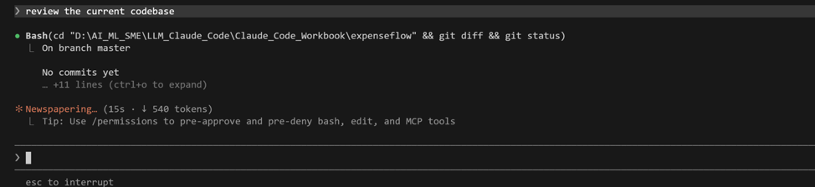
What success looks like
- You ran both /review and /security-review and can describe how their focus differs.
- You pushed a too-gentle review into a ranked, actionable one, then fixed the top issues.
- The re-review and the test suite both confirm the fixes held with no regressions.
Common pitfalls (Windows and macOS)
- A first review that says 'looks good overall' is a prompt problem, not a code-quality fact. Demand ranked severity and specifics.
- Fixing all twenty findings at once makes the diff unreviewable and risks regressions. Fix in small, tested batches.
- Security findings about .env or the API key are the ones to take most seriously, especially anything that would touch real customer data later.
Stretch goal
Ask for the review as a checklist you can reuse: 'turn your review criteria into a reusable REVIEW.md checklist for this project'. You have just started building your own review standard, which becomes a Skill in the next exercise.

